Hope for lifers in New York
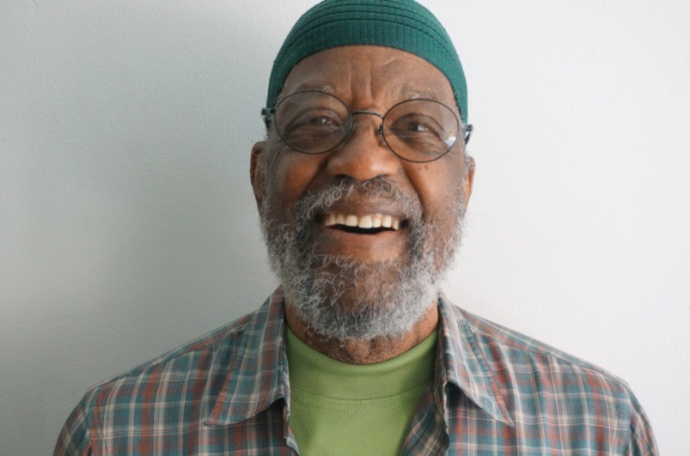
While incarcerated in a New York prison, Larry White began developing a manual for people serving long-term sentences. Photo: AFSC/New York
Larry White is the founder of Hope Lives for Lifers, a project of AFSC in New York. But his work really began during the 32 years he spent at Green Haven Correctional Facility.
LW è il fondatore di HLfL, un progetto di AFSC a NY. Ma il suo lavoro iniziò per davvero durante i 32 anni che spese alla prigione di Green Haven.

Now 80 years old, Larry remembers growing up in Brooklyn in the 1930s and ’40s. He knew early on that his family didn’t have much. As a young child, he would wake up at 4 a.m. to steal food from the early-morning deliveries made to the grocery store down the street.
Ora che ha 80 anni, Larry si ricorda della sua infanzia a Brooklyn nel anni Trenta e Quaranta. Seppe ben presto che la sua famiglia non possedeva un granché. Da bambino, si alzava elle 4 del mattino per andare a rubare quando avvenivano le consegne delle merci all’alimentari sotto casa.
“I made up my mind early—all the things that other people had, I was gonna get on my own,” he says.
“Feci presto a capire che tutto ciò che gli altri avevano, io dovevo procurarmelo per conto mio”.
Throughout much of his youth, Larry was in and out of trouble. He was 14 years old the first time he landed in a juvenile detention facility. Mostly theft. Burglaries. The last sentence he would serve started in 1975, when he received 25 years to life for an armored truck robbery in which two people were killed.
Durante buona parte della sua gioventù, Larry ricadeva nei pasticci. Aveva appena 14 anni quando per la prima volta fu rinchiuso in un carcere minorile. Principalmente per ladrocinio

“The prospect was both frightening and overwhelming for me,” Larry says. “When you get that kind of sentence, nobody sits you down and tells you how to go about serving it.”
His survival had a lot to do with the strategy he developed to live out those years. “I established two principles of confinement—to earn my release from prison as quickly as possible and to leave prison in better condition than when I came in,” he says.
To reach that goal, he mapped out the next 25 years, dividing his time into five-year increments. For each increment, he set shorter-term goals—educational, family-related, spiritual, and so on—and worked to accomplish them.
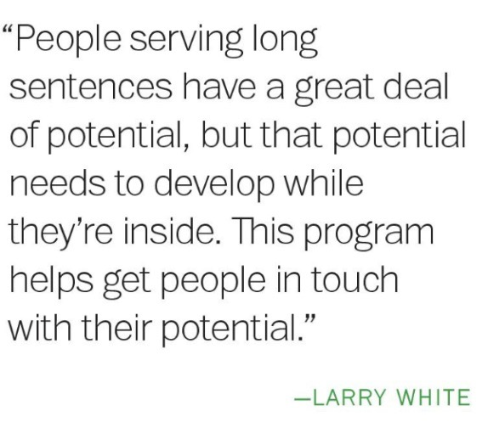Larry followed prison rules. He ran the prison newspaper. He became a mentor for younger inmates, sharing his approach to serving his sentence. In time, he helped found the Think Tank, a support group for people serving long-term sentences, under the guidance of prison chaplain the Rev. Ed Muller. The Think Tank was in turn instrumental in launching the Alternatives to Violence Project, which got its start in the 1970s when the prison group invited Quakers to Green Haven to discuss ways to teach younger inmates about resolving conflicts without violence.
“No one is going to tell you how to do this—you have to evolve yourself,” Larry says. “I studied literature on confinement and talked to others about developing a road map to survive long-term prison sentences.”
The manual that Larry began formulating in prison, “Beyond the Yard: Constructing a Prison Life,” will soon become a resource for people throughout the New York state prison system, as the Department of Corrections has agreed to distribute the publication to inmates serving long sentences. Several groups contributed to the manual’s development: Exodus Program, led by the Rev. Muller; the Association of Black Psychologists; Be the Evidence, based out of Fordham University; Community Service Society of New York; and Aging Resources Consultation and Help, run by the New York Yearly Meeting.
Over the past year, AFSC and Exodus have piloted the Hope Lives for Lifers program in Eastern Correctional Facility, coordinating prison group discussions using the manual as a guide. They plan to expand the program to other prisons by the end of this year.
“People serving long sentences have a great deal of potential,” Larry says, “but that potential needs to develop while they’re inside. This program helps get people in touch with their potential.”
—RONNA BOLANTE

