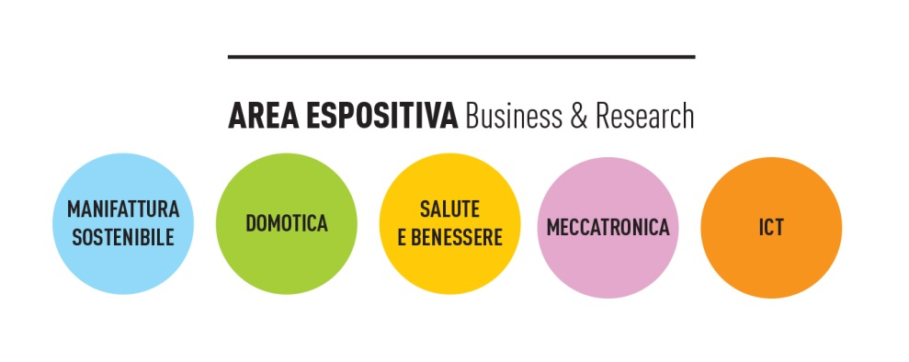

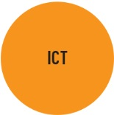
- PLUSERVICE SRL
- FILIPPETTI S.P.A.
- SERVILI COMPUTER SRL
- HYPERLEAN SRL
- CEDAR SOLUTIONS S.R.L.
- E- LINKING ONLINE SYSTEM SRL
- DIGITALES SRL.
- INFOR MA SRL UNIPERSONALE
- L@TECA DIGITALE SRL
- LEAFF ENGINEERING SRL
- RETE DI IMPRESE "GEOSHOES" 4D ENGINEERING SRL - CALZATURIFICIO MONTEBOVE SPA - SP PLAST CREATING SRL - TIGAMARO SRL - BLUE STAR SRL - V.R.L. DI LATTANZI GIANFRANCO & C. SNC
- RETE DI IMPRESE "B3WORLD" BOOKERANG SRL - GIANFRANCO BUTTERI SRL - G.N.V. SRL - ROBERTO MORELLI SRL - CALZATURIFICIO GIUSTI SRL - ENRICO GIBELLIERI SRL
- SI2G SRL - EVE - ENJOY VISUAL EXPERIENCES SRL
- ESALAB SRL
- NAUTES SPA
- A TLC SRL
- IDEA - INFORMATICS, DOMOTIC ENVIRONMENT AND AUTOMATION SOC. COOP.
- GROTTINI LAB SRL
- FAB LAB SRL
- MINDXUP SRL

- APRA SPA
- SISTEMICO SRL
- ARCO INDUSTRIE SRL
- ME.TE.DA. SRL
- METALDESI SRL
- AUTOMA SRL
- ENERLAB SOCIETÀ COOPERATIVA
- PENSY SRL (PRO_ENERGY_SYSTEMS SRL)
- GEOSERVICE SRL
- OVEROUT SRL
- VIDEOWORKS SPA
- SMART SPACE SOLUTIONS SRL
- ITC ITALIAN TECHNOLOGY CENTER SRL
- IGUZZINI ILLUMINAZIONE SPA
- ECTSYSTEM S.R.L.
- SSG SRL - EUROSYSTEMS SRL - JEF SRL
- MAC SRL
- PEDINI SPA
- FABER S.P.A.
- LUBE SERVICE & ENGINEERING S.R.L.
- SPES SCPA
- INDESIT COMPANY SPA
- SALVATELLI SRL
- RUAHCREA SRL
- CBI EUROPE SPA
- TECNOWIND S.P.A.
- FAGGIOLATI PUMPS S.P.A.
- ISIDE SRL
- IDEA COMPANY SRL
- IN.CO.M. SRL
- GALASSI S.N.C. DI GALASSI ROBERTO E RENZO
- EUROSUOLE SPA - GOLDENPLAST SPA
- SPAZIO INFINITO SOC.COOP.
- MENGUCCI SRL COSTRUZIONI SRL
- ENZO RESCHINI SRL
- GRUPPO LOCCIONI - AEA S.R.L.
- ELICA SPA
- NUOVA SIMONELLI SPA
- AMELI MARIO
- ZANNINI S.P.A.
- OLTREMARE SRL
- DELTA SRL
- S.T.A. 2000 SRL
- SPINOSI SRL
- ITAL.E SRL

- TRE P ENGINEERING SRL
- VEGA SRL
- ITACA SNC DI MALVATANI EMANUELE E C.
- MECCANICA H7 SRL
- MECCANOTECNICA CENTRO SRL
- SCANNY3D SRL
- TEST'ING SRL
- SYNBIOTEC SRL
- ERYDEL SPA
- SOL SPA
- BIOLAB SRL
- DIATHEVA SRL
- DIATECH PHARMACOGENETICS SRL - DIATECH LABLINE SRL
- B.M.E.D. SRL
- ARIELAB SRL
- DUNA S.R.L.
- TEUCO GUZZINI SPA
- LABORATORIO DELLE IDEE SRL
- LOGICAL SYSTEM SRL
- COOSS MARCHE ONLUS SOC. COOP. P.A.
- ADITECH SRL

